VIKKY ALEXANDER

THEATERGARDEN BEASTIARIUM

September 20 – November 1, 2014

Artist Reception:
Saturday, September 20, 2014, 6-8pm
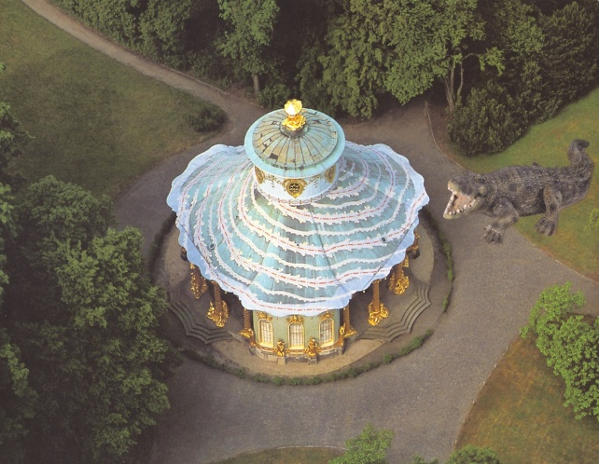

LOS ANGELES - Wilding Cran Gallery is pleased to announce Theatergarden Beastiarium, a new body of work by Vikky Alexander on view September 20 – November 1, 2014. The exhibition marks Alexander’s first solo show at the gallery. Theatergarden Beastiarium presents the artist’s latest photo-collage work and explores her ongoing tension between nature and culture.

Alexander’s new series combines found images of animals with postcards of historic buildings, architectural marvels, museums, palaces and gardens that she has collected during her travels over the last 30 years. She sources her images of animals from a catalogue published by Schleich, a German toy company renowned for producing anatomically correct miniature figurines. She combines the found animal images with her postcards of various scenes around the world.

The animals are juxtaposed with venues that are far from their natural habitats, such as an alligator positioned in a carousel scene at Park Sanssouci in Potsdam, Germany or a lynx cub resting in the Wallace Collection Drawing room in London. Whether alone or in a group, in a formal interior setting or on the grounds of an estate, the beasts begin to resemble examples of 18th Century portraiture, the type commissioned by dukes and kings, to illustrate their wealth, lands and progeny.

The small, standard post-card size collages are scanned and presented as large format-photographs. The toy figures are instantly transformed to beasts and dominate the diverse tourist attractions represented in the postcards. The abrupt changes in size and scale and the absurdity of animals inhabiting culturally historic sites lends a surreal quality to these works, while at the same time the animals placed in these locations, seem strangely at home.

Alongside her photo-collage work, Theatergarden Beastiarium will also include a selection of intricate graphite drawings that Alexander started in Paris in 2009. The drawings depict various pavilions that were designed by M. de Monville for his French Folly Garden, ‘Le Desert du Retz,’ located just outside of Paris and completed in 1789 on the eve of the French Revolution. In the drawings, exotic and wild animals have been placed in front of various follies and pavilions in the garden. The animals look out of place, as if they were set free from the zoo and suddenly became aware that they are in a completely artificial environment, not their natural habitat. Alexander has added subtle color to highlight certain areas of the picture.

About Vikky Alexander
Vikky Alexander is one of Canada’s most acclaimed artists. Her work has been recognized internationally in New Zealand, Japan, Korea, Europe and in the United States. Working as a photographer, sculptor, collagist and installation artist, Alexander is a leading practitioner in the field of photo-conceptualism. Her work is held in private and public collections around the world including, Deste Foundation, Athens, Greece, Hammer Museum, UCLA, Los Angeles, California, The Museum of Contemporary Art, Los Angeles, and International Centre for Photography, New York.

Alexander’s work is described as fantastic in both the literal and figurative sense. She is playful and uses a variety of media and techniques throughout her work, such as mirrors, photographic landscape murals, postcards collected on her travels, her own photography and video. Her work is at once both seductive and disruptive; she likes to situate the viewer within idealized spaces that reflect aspirations and utopian desires.

Vikky Alexander has been a professor in the Visual Arts Department at the University of Victoria since 1992. She lives in Vancouver. Visit www.vikkyalexander.com for more information.

About Wilding Cran Gallery
Naomi Wilding and Anthony Cran established Wilding Cran Gallery in 2012 as a virtual platform committed to supporting the practice of contemporary art by emerging, mid-career and established artists. In April 2014, the gallery launched a physical space in the Arts District of Los Angeles to connect with the growing art community and be a platform to present the gallery’s expanding roster of contemporary artists. Wilding Cran Gallery is open Thursday and Friday from 11– 4pm, Saturday from 12- 7pm and also by appointment. Visit http://www.wildingcran.com for more information.

###

Media contact:
Jessica McCormack,
213-453-9000
jessica@wildingcran.com

